C programming
NAME : YOKITHA S
ROLL NO: 241801327
WEEK : 12
TOPIC : USER-DEFINED FUNCTIONS AND RECURSIVE FUNCTIONS
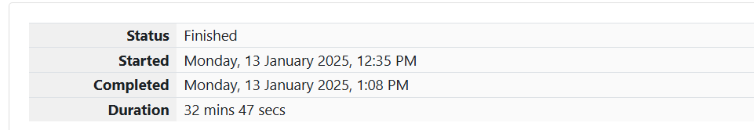
1.

Problem Statement: 4th Bit
A binary number is a combination of 1s and 0s. Its nth least significant digit is the nth digit starting from the right, starting with 1. Given a decimal number, convert it to binary and determine the value of the 4th least significant digit.
Example
- number = 23
Convert the decimal number 23 to binary:
2310=24+22+21+20=(10111)223_{10} = 2^4 + 2^2 + 2^1 + 2^0 = (10111)_22310​=24+22+21+20=(10111)2​
The value of the 4th index from the right in the binary representation is 0.
Function Description
Complete the function fourthBit in the editor below.
fourthBit has the following parameter:
- int number: a decimal integer
Returns
- int: an integer (0 or 1) matching the 4th least significant digit in the binary representation of number.
Constraints
- 0≤number<2310 \leq \text{number} < 2^{31}0≤number<231
Sample Input
Copy code
32
Sample Output
Copy code
0

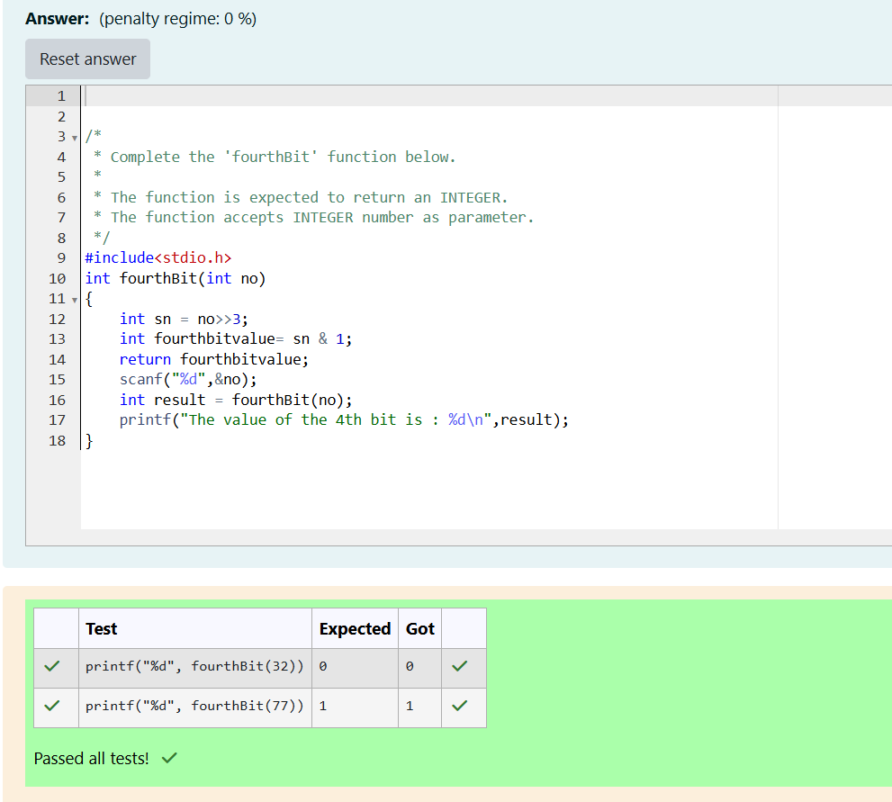

2. Problem Statement: Find the Factor
Determine the factors of a number (i.e., all positive integer values that evenly divide into a number) and then return the p-th element of the list, sorted in ascending order. If there is no p-th element, return 0.
Example
- n=20n = 20n=20
- p=3p = 3p=3
The factors of 20 in ascending order are {1, 2, 4, 5, 10, 20}. Using 1-based indexing, if p=3p = 3p=3, then 4 is returned. If p>6p > 6p>6, 0 would be returned.
Function Description
Complete the function pthFactor in the editor below.
pthFactor has the following parameters:
- int n: the integer whose factors are to be found
- int p: the index of the factor to be returned
Returns
- int: the long integer value of the p-th factor of nnn or, if there is no factor at that index, 0 is returned.
Constraints
- 1≤n≤10151 \leq n \leq 10^{15}1≤n≤1015
- 1≤p≤1091 \leq p \leq 10^91≤p≤109
Sample Input
Copy code
10
3
Sample Output
Copy code
5

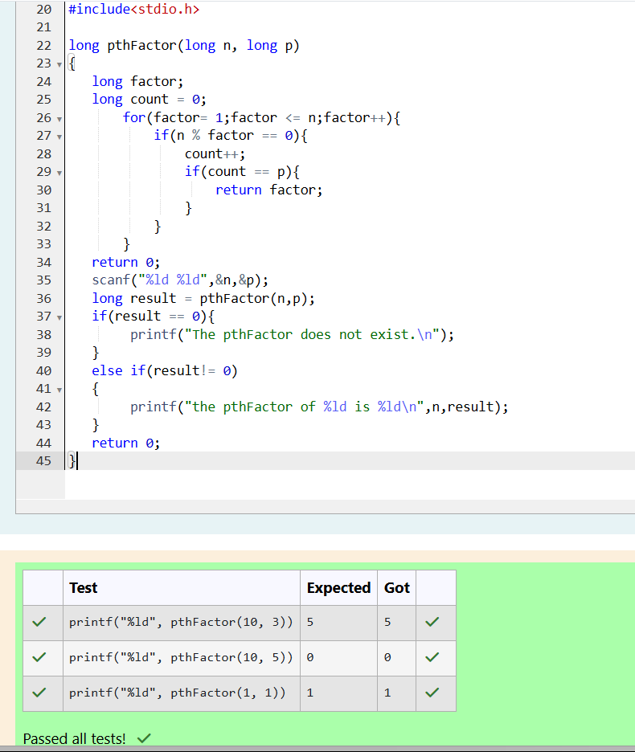

3. Problem Statement: Hack the Money
You are a bank account hacker. Initially, you have 1 rupee in your account, and you want exactly NNN rupees in your account. You wrote two hacks:
- The first hack can multiply the amount of money you own by 10.
- The second hack can multiply it by 20.
These hacks can be used any number of times. Can you achieve the desired amount NNN using these hacks?
Constraints
- 1≤T≤1001 \leq T \leq 1001≤T≤100
- 1≤N≤10121 \leq N \leq 10^{12}1≤N≤1012
Input Format
- The test case contains a single integer NNN.
Output Format
- For each test case, print a single line containing the string "1" if you can make exactly NNN rupees or "0" otherwise.
Sample Input
Copy code
1
Sample Output
Copy code
1

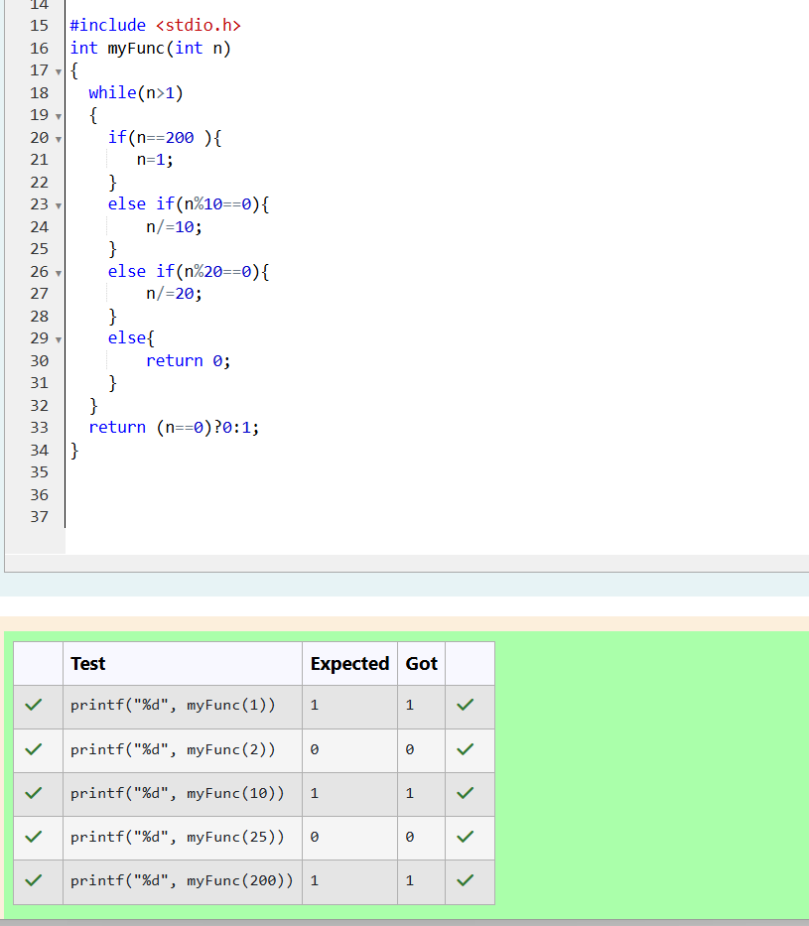

4. Problem Statement: The Power Sum
Find the number of ways that a given integer XXX can be expressed as the sum of the NNN-th powers of unique, natural numbers.
Example
If X=13X = 13X=13 and N=2N = 2N=2, we need to find all combinations of unique squares adding up to 13.
The only solution is 22+322^2 + 3^222+32.
Function Description
Complete the function powerSum in the editor below. It should return an integer representing the number of possible combinations.
powerSum has the following parameters:
- X: the integer to sum to
- N: the integer power to raise numbers to
Constraints
- 1≤X≤10001 \leq X \leq 10001≤X≤1000
- 2≤N≤102 \leq N \leq 102≤N≤10
Sample Input
Copy code
10
2
Sample Output
Copy code
1

